Slow Cooker Eight Can Soup

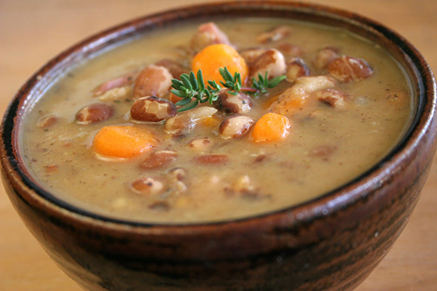
- 1-pound ground beef – browned, drained, rinsed
- 1 can whole kernel corn (yellow or white)
- 1 can mixed vegetables with water too
- 1 can diced potatoes with water too
- 1 can seasoned diced tomatoes with juice
- 1 can chili with beans
- 1 can chili without beans
- 1 can diced tomatoes with juice too
- 1 can tomato soup

Combine all ingredients in large slow cooker and cook on low for 5 hours or on high for 3 hours.

